|  |
| --- |
| The University of Hong Kong  Faculty of Engineering  Department of Computer Science  COMP7704  Dissertation Title  Real-time Speaker Recognizer  Submitted in partial fulfillment of the requirements for the admission to the degree of Master of Science in Computer Science  By  Pan Hao  3035349015  Supervisor's title and name: Dr. Beta C.L. Yip  Date of submission: 01/07/2019 |

**Abstract**

Speaker diarization has become more important in many speech processing tasks. Most state-of-the-art speaker diarization system decodes in an offline fashion and requires intensive computation and long processing time, which leads to the handicap for real-time applications. In this paper, we implemented the binary key speaker modelling approaches and built a fast offline speaker diarization system that can label the speakers in recorded audio, with visualization and audio player panel. An advanced version of the system is also developed, which can process in real-time with acceptable delay and correct earlier outputs when necessary.

Keywords: Speaker diarization, binary key speaker modelling, speaker clustering, MFCC

***The abstract should not be more than 200 words.***

**Declaration**

Table of Contents

1. Introduction 3

1.1 Overview 3

1.2 Offline, online and real-time diarization 5

1.3 Scope and aim 6

1.4 Organization of the paper 8

Analysis of problem 10

Theoretical principles 11

Method of investigation 11

Design and construction of software system 11

Design of the speaker diarization system 12

Design of the Visualization Panel 26

Theoretical/Algorithmic/Experimental results 29

Discussion/Analysis of approach/results 29

Conclusions 29

Bibliography 32

# Introduction

## 1.1 Overview

With the boom of broadcast radio, TV channels and Internet, large volumes of audio or spoken documents are created and archived every day. Because of the difficulties and complexities of accessing and analyzing audio documents manually compared to text document, there is a growing need of using automatic audio processing technologies to efficiently index, search, access and analyze the information from audio data. The development of audio streaming also demand the real-time application of these technologies.

In many scenarios in presence of multiple speakers including conversations, meetings, conference and broadcast news, there are multiple audio sources or multiple speakers speaking within one audio channel. Speaker diarization is the process used in these cases to segment an input audio stream into speaker-homogeneous segments. Therefore, it is often summarized as “who spoke when” question [1]. The main difference between the speaker diarization and speaker recognition or speaker verification is that there is no speaker enrollment in the former so speaker identities are completely unknown. Another difference is that the temporal information are more important for speaker diarization than other speaker processing tasks.

Speaker diarization is a vital area in the community of speech processing because it provide the metadata in the audio of multiple speakers including the speaker segment labels, position of speaker turns and number of speakers, which can provide more context of the speech and be used for information retrieval. In the scenario of two speakers, for instance, doctors and patients in medical recording or customer and customer service in telephone conversation, speaker diarization can be used as source separation tool so that the further analysis on the speech of each side can be performed more easily. Another important application of speaker diarization is to find the boundary of sentences in conversation and the corresponding speakers of the sentences, to improve the readability and overall accuracy of the automatic speaker recognition (ASR) system. Generally, speaker diarization is an important front-end tool such that the audio information output can be more efficiently used as input in multiple speech processing tasks including spoken document indexing and retrieval, speaker recognition and speech-to-text transcription [2].

The traditional three primary application domains of speaker diarization is telephone conversation, broadcast news and conference meetings [3]. The audio streams from these domains are different in style of the speech, style of the noise source, numbers and locations of microphones, configuration of environment and therefore present unique challenges. [4] makes detailed comparison between broadcast news and conference meetings. The majority of the literature in speaker diarization will only focus on one of the three cases and some propose specific techniques to tackle some unique problems. For instance, [5] propose the acoustic beamforming technology to take advantage of the multiple microphones available in the meeting room domain to facilitate the speaker diarization process. Therefore, the speaker diarization system that has advantageous performance in one domain may not have comparable performance in other domains, and this domain-specific problem negatively affect the usability and extensibility of some systems.

## 1.2 Offline, online and real-time diarization

While the majority of the past works aim at improving the accuracy of the speaker diarization system on recorded audio, there is limited work aims at improving the speed of the diarization system and the possibility of real-time application.

Speaker diarization system can be differentiated as offline and online system. The offline system can access the whole audio recording before processing, and the clustering step is performed only when complete audio stream has been segmented. This means it is hard to adopt an offline diarization techniques in real-time applications where the audio processing has to be conducted simultaneously or with acceptable latency when the audio is input.

Online diarization, on the other hand, only have access to the audio data up to the point that is been recorded, which means the diarization have to perform in a “left-to-right” fashion [6] that process and assign the segments once they are created and detected in the audio stream. Therefore, online speaker diarization are more suitable for real-time applications. However, offline speaker diarization is still the main focus in the field of speaker diarization [4] and there is limited work on online speaker diarization. A real-time speaker diarization system for the meeting environment is proposed in [7]. However, the system relies on the speaker seat locations and has the limitation of detecting only one speaker in one frame even if there are multiple speakers speaking. The online speaker diarization based on Gaussian mixture models (GMMs) and male, female and noise models, are tested with broadcast news data [8]. However, this system has difficulties dealing with speech overlapped by music. The novel Maximum a Posteriori (MAP) adapted transform within the i-vector speaker diarization framework proposed in [6], have a preferable diarization result for two-person telephone conversation audio, but still have diarization error rate (DER) 50% worse than offline system. Generally, the performance of the online system is much worse than that of the offline system, but recently, a state-of-art online system that used Unbounded Interleaved-State Recurrent Neural Network (UIS-RNN) algorithm is demonstrated to have performance that is comparable with offline diarization [9]. The UIS-RNN model that used to predict speakers labels, is learned in a supervised manner, given the speaker label with temporal information and speaker-discriminative embedding (d-vectors) extracted from training data. Therefore, this process require large training data that incorporate temporal data and the diarization results will be significantly affected by the quality of the speaker embedding and not robust for different domains if the training data of UIS-RNN is domain-specific. Another obstacles for this method in real-time application includes the complexity and large computational resources required for the system.

## Scope and aim

Given the limited research on the speed of the speaker diarization system and the gap of the real-time speaker diarization system, the general aim of this dissertation is to build a fast offline speaker diarization system that can label the speakers in recorded audio, and developed an advanced version of the system that can perform diarization in the real-time context.

As presented in Chapter 1.1, different application domains presents unique diarization challenges. This dissertation will not focus on any domain specific challenges and aims at building a system that is domain-robust for different domains. Broadcast news audio will be firstly considered for training or testing purpose in this dissertation, because of the availability of the audio data and the higher difficulties to processed, due to the fact that there are more people speaking comparing with telephone conversation and more noise and interruption comparing with conference meeting.

The scope of this dissertation is restricted to the audio signal processing techniques in speaker diarization context, so no information other than input audio signal itself, can be used in the proposed system. The speaker diarization techniques that incorporate information that is not from the audio signal such as environment configuration including seat and microphone location [7], and visual activity sensing including face tracking [10] and focus of attention tracking [11], to assist speaker diarization, are all out of the scope of this dissertation.

Speaker diarization assumes no prior information of speaker identities and number of speakers for the input audio available. In this dissertation, these information will also be unknown and no speaker enrollment process is designed in the system. The speaker recognition or speaker detection tasks that have the access to the voiceprint of the speakers within the audio, is out of the scope of this dissertation.

This dissertation will only consider the design of the software system without special requirement on the hardware architecture. The specialization framework proposed in [12] to perform parallel implementation of GMM training on GPU to to speed up the diarization system falls outside the scope of this dissertation.

As the limited work on online diarization system and the importance of the speaker diarization for real-time applications, the objective of this dissertation is to build a real-time speaker system that fulfills the following requirements:

1. The system can perform speaker diarization for recorded audios like radio talk or phone conversation;
2. The system can perform speaker diarization in a real-time fashion, that can process the live speech audio and generate output as the input is analyzed;
3. The system should be language-independent and operating-system independent;
4. The system should not require the number of the speakers, identity of the speakers or the voice samples of the speakers for the training.

## 1.4 Organization of the paper

The remaining chapters of this paper will be organized as follows

Chapter 2 analyses the research problem and provide an overview of existing speaker diarization system.

Chapter 3

Chapter 4

Similar to other speaker processing tasks, input audio signal is preprocessed before being segmented and clustered in the speaker diarization system. The voice activity detection / speech activity detection and feature extraction are two fundamental tasks in the majority of the speaker diarization system. Other domain-specific signal preprocessing techniques are also investigated such as noise reduction using Wiener filtering [13] and multi-channel acoustic beamforming firstly proposed in [14] , to improve the overall performance.

Speaker diarization can also be referred as speaker segmentation and clustering, as the majority of diarization approach consist two main steps of segmentation and clustering [15]. Speaker segmentation aims at splitting the original audio stream into segments containing one active speaking speaker and many other literatures adopt speaker change detection (SCD) techniques to fine the speaker change points in the audio [2, 3] . One popular segmentation algorithms is the use of Bayesian information criterion (BIC) firstly introduced in [16] and firstly used in speaker segmentation in [17]. Many state-of-art systems incorporate BIC as a segmentation metric in the following [14, 18]. As BIC approach is computationally intensive, several works (e.g. [19]) propose modification or other technologies used with BIC to speed up the process. Some common alternative segmentation approaches include Generalized Likelihood Ratio (GLR) [20] and Kullback–Leibler (KL) divergence [21]. Some recent papers propose advanced machine learning technology including deep neural network (DNN) to find speaker change points [22].

Clustering, on the other hand, focus on agglomeration of segments from segmentation step into groups that from the same speaker. One of the popular approaches recently is unsupervised i-vector clustering. [23] propose a system that uses i-vectors and probabilistic linear discriminant analysis (PLDA) which has preferable performance for multi-language telephone conversation data.

1. ***the subject matter and the scope of the investigation,***
2. ***the purpose of the dissertation,***
3. ***the organisation of the report.***

***If applicable, a brief survey of previously published work and current trends may be included in this section.***

# Analysis of problem

# Theoretical principles

# Method of investigation

# Design and construction of software system

In this section, the discussion of the design and construction of the software system will be divided into three subsections: the design of the speaker diarization system, the adaptions of the real-time system and the design of the visualization panel. The algorithm that is applied and the reason to choose a certain algorithm will be presented.

## Design of the speaker diarization system

The workflow of the proposed speaker diarization system is presented in Figure 1 and it consists of below main blocks:

1. Voice activity detection block to detect and remove the regions of silence from the input audio
2. Acoustic feature extraction block to compute the Mel Frequency Cepstral Coefficients (MFCCs) from non-silent region of the input data to form to a features vector
3. Segmentation block to divide the non-silent audio regions into segments that contains one active speaker
4. Binary Key Background Model (KBM) Training block to train the MFCCs from step 2) to obtain the KBM that model the acoustic space of the audio
5. Feature Binarization block to transform the vector of features of segments or clusters into Cumulative Vector (CV) and Binary Key (BK), which is used as the representation of segments or clusters
6. Clustering block to merge the segments into clusters of homogenous speakers based on the CVs or BKs
7. Resegmentation block to refine the clustering result

Step 4) and 5) constitutes the Binary Key (BK) speaker modelling, which is the heart of this system.

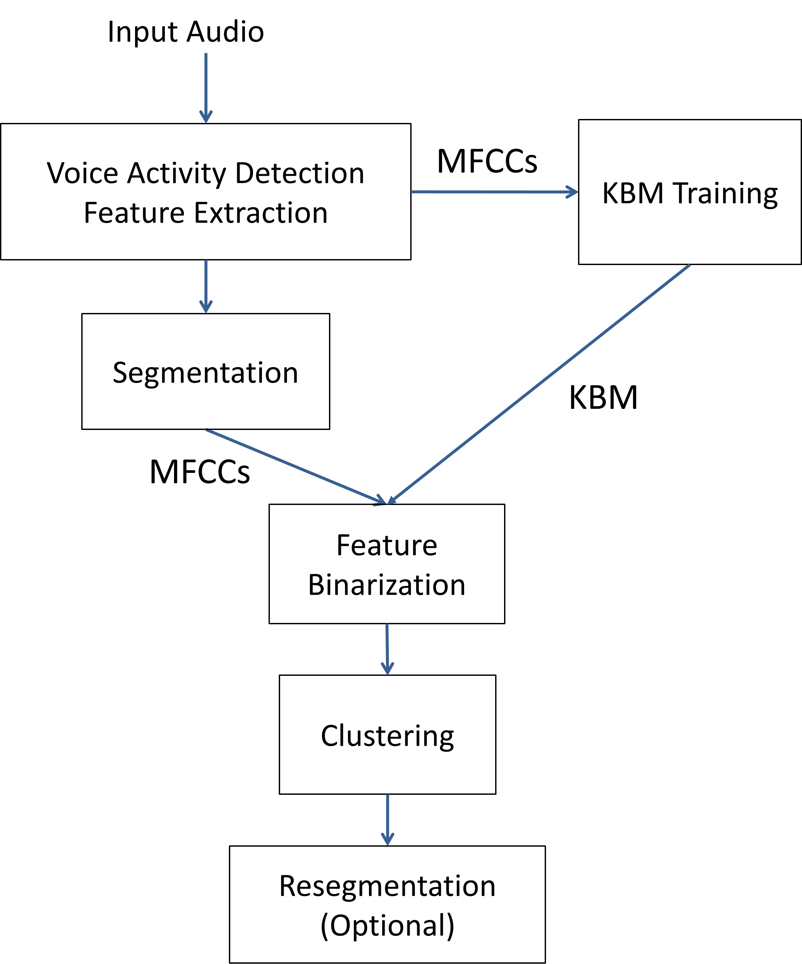

*Figure 1 System workflow*

The role of each step and the classic design in existing system will be presented in the following. The algorithm we have adopted in our system and the corresponding design idea will also be further explained respectively.

**Voice Activity Detection**

Voice activity detection (VAD) or speech activity detection (SAD) is included in the majority of the speaker diarization system. It is used to identify the region of the audio data that is being voiced or containing speech, from the unvoiced or non-speech regions that contain silence or background noise. Energy-based voice detection and model-based voice detection are two main approaches of VAD. The energy-based voice detection removes the silence part based on the energy level and has the advantage of simplicity and speed. However, this approach fails to distinguish the load noise from the speech, and therefore is ineffective in many application domains of speaker diarization [24, 25]. To avoid the limitation of energy-based detection, model-based detection that is developed on the different acoustic phenomena, are more frequently used in speaker diarization system [26].

The model-based VAD algorithm that Google developed for the WebRTC project [27] will be applied in the design of our system, the reason includes:

1. The WebRTC project targets on real-time capabilities and its VAD algorithm has been widely used for different delay-sensitive scenarios [28], which is suitable for our offline and real-time applications.
2. The free and open-source implementation of the algorithm is available and there is Python interface (Py-webrtcvad [29]) that is well-suited for our development.

The VAD process in the system can be performed on the all audio data for the audio recording or the new input data for real-time audio stream. The result of the VAD is a mask vector that used to exclude the data segments or the acoustic features that contains no speech from the original data.

**Feature extraction**

The raw audio data is usually converted into a sequence of acoustic feature vectors that contains speaker specific information before the segmentation and clustering. This feature extraction step try to acquire the acoustic features that contain formant information, model the mode of excitation and/or the shape of the vocal tract when people producing speech [26]. Common features include Mel Frequency Cepstral Coefficients (MFCC), Linear Predictive Codes (LPC), Linear Prediction Cepstral Coefficients (LPCC) [30] and constant Q transform Mel-frequency Cepstral Coefficients (ICMC). These features are different in frequency analysis and frequency smoothing techniques.

In this dissertation project, the focus will be put on the MFCCs which are frequently used in the community of speaker diarization and more specifically, the online speaker diarization system [8, 6]. Librosa, the python library for music and audio analysis [31, 32], will be used to extract the MFCCs. The python code is simple and straightforward as below:



**Segmentation**

Speaker segmentation or speaker change detection (SCD) in many literatures, aims at finding the speaker change points in the audio so that splitting the original audio stream into segments that contains only one speaker [2, 3]. Although many system will used various distance metric to decide whether the speech of the adjacent windows are from the same or different speakers, a simple method that use fixed-sized windows to splits the audio into small equal-sized segments, will be used in our system.

**BK Speaker Modelling**

The speaker modelling is the heart of the many state-of-art speaker diarization system, and the similar step is called embedding extraction in some other research. This step aims to find speaker-discriminative identifiers that can be used to distinguish unique speaker from each other. Some models or embeddings are first found to be effective in speaker recognition or identification tasks, and then are adopted in speaker diarization tasks. Famous speaker models used in state-of-art system include Gaussian Mixture Model (GMM) and Hidden Markov Model (HMM) and famous speaker embeddings include speaker factors [33], i-vectors [6] and d-vectors [34].

In this project, we will adopt the Binary Key (BK) speaker modelling techniques that is firstly proposed in [35] and later used in speaker diarization context in [36]. This technique has advantages of being domain-robust, requiring no external training data and running faster than real-time, so therefore can be utilized for our offline and real-time system.

The process of BK speaker modelling can be divided into two steps: KBM training and feature binarization, which are further explained as below.

**KBM Training**

The first step of the binary key speaker modelling is to train a GMM-like model called KBM from the acoustic features (MFCCs for our system) extracted from the input data. While the majority of the speaker modelling or speaker embedding extraction techniques requires large amount of external training data that is from the same domain of the tested data, the BK techniques train the KBM directly from the input tested data. Therefore, BK modelling is domain-robust and can avoid the negative impacts from the mismatch of the acoustic conditions between training and tested datasets.

Figure 2 shows the process of KBM training. To obtain the KBM, multiple Gaussians are trained on the data that is separated by a 2-second sliding window on the input features data. The mean and the standard deviation of the 2-second data will be calculated to get the Gaussian, which will be realized by multivariate_normal function from scipy library [37] in Python. The shifting rate of the sliding window is determined automatically to have enough number of Gaussians. All resulted Gaussians form a Gaussian pool that covers all acoustic space in the input audio. Then *N* Gaussians are selected from the pool using single-linkage clustering strategy with cosine similarity as similarity measures. The first Gaussian is selected with maximum likelihood and the Gaussians with highest dissimilarity with previously selected Gaussians is selected subsequent until getting *N* Gaussians. Then the KBM is formed by these *N* Gaussians, which are considered the most complementary and discriminat Gaussians that can be used to represent the speaker acoustic space. The number *N* can be a fixed number or be determined relatively by a percentage of the total number of Gaussians in the pool.

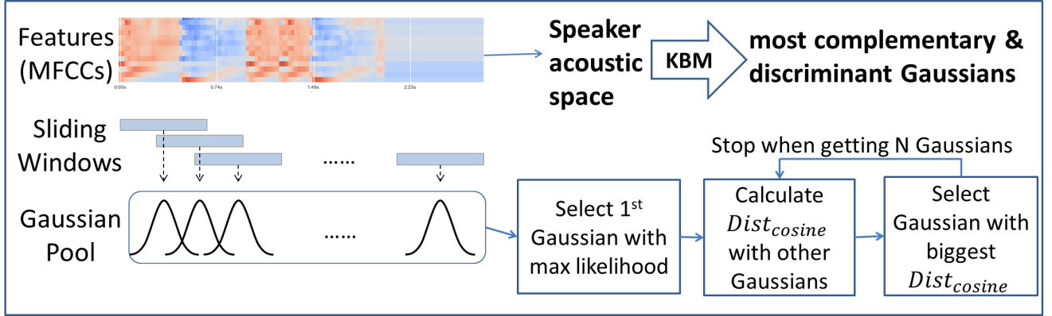

*Figure 2 KBM Training*

Although KBM is a GMM-liked model and GMM trained on the test data can also be used to produce speaker discriminative representation, [36] and [35] demonstrates that the KBM outperform classic GMM in distinguishing the speakers. Moreover KBM has the advantage of lower computational cost and consequently shorter processing time, comparing the expectation-maximization algorithm in GMM training.

**Feature binarization**

The second step of the binary key speaker modelling is the feature binarization that transforms feature vectors of an utterance to into a binary key, and this process is shown in Figure 3.

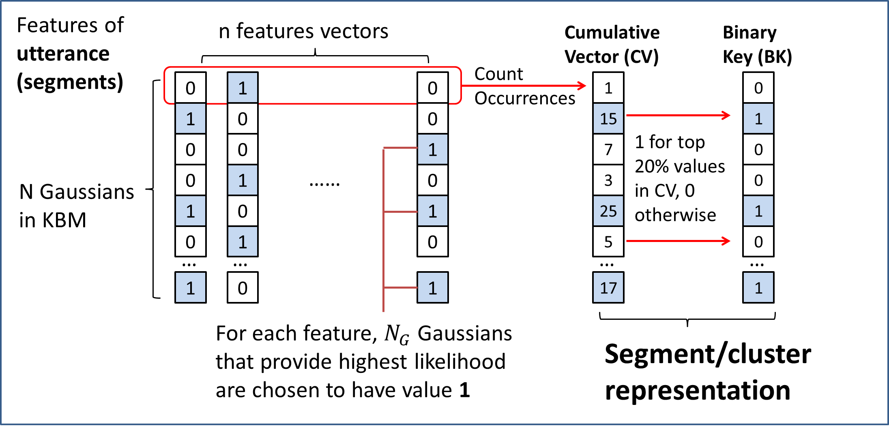

*Figure 3 Feature Binarization*

Firstly, a matrix with number of rows equal to *N* (size of KBM) and number of columns equal to number of feature vectors are created. For each column of each feature vector, $N_{G}$ rows representing the Gaussians that provide highest likelihood for the given features are chosen to have value 1. All other rows in this column are set to have value 0. This process recorded the best $N_{G}$ Gaussians from the KBM that represent each features. Secondly, we sum the values of each row, to form a vector called Cumulative Vector (CV) of size *N*. This CV contains the count of the occurrences of each Gaussians has been selected as the top-likelihood Gaussian for all feature vectors, so intuitively the larger number in the CV indicates higher impact of the corresponding Gaussian components. Thirdly, the binary key (BK) is obtained by setting the value as 1 for the positions that have top M% values in CV and the value as 0 for the other positions. For example if M equals to 20, then the positions whose values in CV are over 80th percentile will be set to have value 1 in BK.

The resulted CV or BK can be used to represent the input utterance and theoretically, the utterances from same speaker will have similar Gaussians in the KBM that have highest impact in modelling the speech, and therefore generate similar CVs or BKs. The input series of features in this step can come from the utterance of a short segment or a speaker cluster. Segment assignments and clustering can be performed by comparing the CVs or BKs from the segment or clusters by some similarity measures.

While the CV store the relative importance of the Gaussian components in KBM, BK only store the components that have greatest impact to fit the input features. Therefore, there is information that is missing in the process of transforming the CVs into BKs. In this project, CV will be considered over BK, as [38] found that CV is more speaker discriminative as the segment / cluster representation comparing with BK.

Because the value in the CV is the number of occurrences of the corresponding Gaussian has been selected for the input feature vectors, the longer feature vectors generally results in CV of larger magnitude. Consequently, to compare two CVs from feature vectors of different sizes, the angle instead of the magnitude of the vectors should be considered. The cosine similarity is therefore proposed as the similarity measures to compare CVs. The computation of cosine similarity between two vectors of positive integer values is simple and fast and the formula is:

$$S_{cos}(x,y)=\frac{x∙y}{\left\|x\right\|\left\|y\right\|}$$

$${,where S}_{cos}\left(x,y\right)∈(0, 1)$$

The value of cosine similarity is between 0 and 1, where values close to 1 indicate high similarity between two CVs, while values close to 0 indicate high dissimilarity.

In programming levels, cosine similarity can be easily computed by cdist function from Scipy library [37] and the pseudo code is:



[] demonstrated the system using cosine similarity have more preferable performance comparing system using KL2 divergences between Gaussians.

will be used as the similarity measures to compare CVs because of its simplicity, speed and preferable performance demonstrated in []. The

**Clustering**

The clustering algorithm can be divided into two categories of the offline clustering and online clustering. The former

**Offline Clustering**

The offline clustering adopted in this system is the bottom-up approach of agglomerative hierarchical clustering (AHC). It is one of the most common approach in the literature of speaker diarization [2]. This approach starts at certain number of clusters and successively merge the clusters and reduce the number clusters by one at each iteration until only one cluster is left. Assume the initial number of cluster is K, then the iterative process generate a set of clustering solutions $C=(C_{1}, C_{2}, …, C_{K})$ with decreasing number of clusters, where solution $C_{1}$ has K clusters and $C_{K}$ has one cluster. Then some clustering selection technique is used to select the best clustering solution from C.

The workflow of the AHC in my system is illustrated in Figure 4. There are many cluster initialization techniques have been studied in previous studies and one of the most common and simple approach is to divide the input audio data into a number of equal-sized chunks. This uniform initialization method generally results in equivalent performance found in [39] and has advantages of simplicity and speed. The initial number of clusters K should be larger than $K_{opt}$, the optimum number of clusters for the audio.

After the cluster initialization, the CVs for the initial clusters are calculated as the cluster embedding using the techniques in Feature Binarizaion. Then the segments of the input data are reassigned to the current clusters, by comparing the CVs of the segments to the CVs of the current cluster by cosine similarity. The segment is assigned to the cluster if highest cosine similarity between their CVs is achieved. After the reassignment, CVs are calculated for the new clusters. Then the cosine similarities will be calculated between the CVs of the new clusters and the cluster pair with highest similarity is merged. The total number of clusters is consequently reduced by one. The CV of the new clusters after merging will be calculated. If there is more than one cluster is left, the iterative process will continue from segment to cluster assignment. For each iteration, the clustering results will be stored to form a set of clustering solutions with size K.

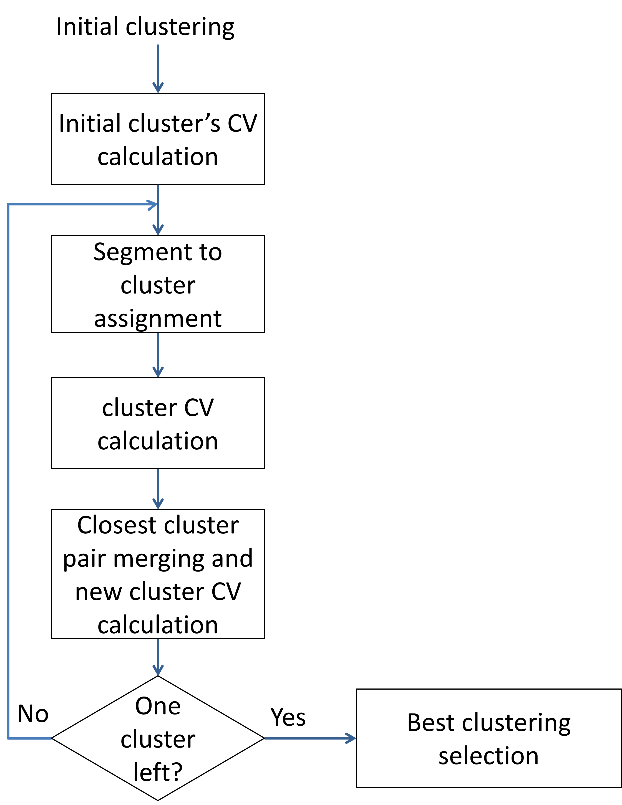

*Figure 4 Agglomerative hierarchical clustering*

Because the segment size is fixed and equal, the calculation of CVs for each segment only need to be performed once. CV of segments can be used to obtain the CV of cluster. Therefore the calculation of CV in this clustering step requires low computational cost. The main computational cost of this step is put on the calculation of cosine similarity between segment and cluster, or between cluster and cluster. The overall processing time required for clustering is short and it is demonstrated in section […]

The best clustering block in Figure 4 is responsible for selecting the best clustering solutions from all clustering solutions generated from previous iteration. Classic criteria to select best clustering includes Kullback-Leibler (KL)-based metrics [40], Generalized Likelihood Ratio (GLR) metrics [20] , T-test $T_{s}$ metric [41]

## Design of the Visualization Panel

A visualization panel for the speaker diarization / recognizer system can help the users to understand and examine the diarization results intuitively. The target of the design of the visualization panel includes:

1. To show the number of the speakers
2. To distinguish different speakers and their speech on the timeline
3. To allow the users to playback the audio to compare with the diarization results
4. To allow the users to choose the start point at the timeline to play the audio and pause it in anytime
5. To use the same programming language as the speaker diarization system

To complete the above targets of the visualization panel, two python modules viewer.py and player.py are designed respectively.

The player.py is the module to open, play and pause the input audio files.

The viewer.py will be used to show diarization results of the input audio or audio stream. The x-axis is the timeline of the audio while the y-axis shows the number of the speakers. Rectangle of different colors will be used to display different speakers and their speech in the timeline. The position and the length of the rectangles will be determined by the position and the length of the speech in the timeline respectively. The Matplotlib library, which is the most popular library in Python for 2D plotting will be used in this part.

[6] 19-dimensional MFCCs (32ms frames ev-ery 10ms using a 24-channel Mel-filterbank) span the fre-quency range of 125-3700Hz.

|  |  |  |
| --- | --- | --- |
| Frame shift for feature extraction | 0.01s | The audio with duration of 100s, will generate MFCCs with length = 100/0.01s = 10000.  the hop length (number of samples between successive frames when extracting MFCCs) = sampling rate * 0.01 |
| Number of mel filters used | 30 |  |
| Number of MFCCs employed | 30 |  |
| Sliding Window length for computing Gaussians | 0.02s |  |
| Minimum number of Gaussians in the initial Gaussian pool | 1024 | The shifting rate of the sliding windows on the MFCCs is determined to ensure there will be 1024 Gaussians trained |
| KBM size | 0.3 * Gaussian pool size |  |
| Top Gaussians per features | 5 | Number of Gaussian component selected for top-likelihood foe each features |
| Number of initial clusters | 16 |  |

# Theoretical/Algorithmic/Experimental results

# Discussion/Analysis of approach/results

# Conclusions

In the Discussion and Conclusions sections, critical evaluation of the techniques employed and results obtained should be carried out. Observations derived from the results should be compared with theoretical predictions. The conclusions should follow logically from the argument and results presented in the report. Recommendations for further investigations may also be included. Supplementary information not essential to the report's main thesis is best included under the heading of Appendices

1. **Objectives**
2. **Methodology**
   1. **Data**

Several databases that the audio recordings are transcribed into speaker segments, are available for training and testing in the development of speaker diarization system.

For meeting environment, sample databases include:

* ICSI Meetings Recorder corpus [42]
* NIST Meeting Pilot Corpus Speech [43]

For telephone conversation, sample databases include:

* LDC CALLHOME English corpus [44] and CALLHOME corpus in other languages are also available.

For broadcast news, sample databases include:

* LDC 1996 radio broadcast news database (HUB4) [45] and an overview of broadcast news corpora is conducted by Graff [46].
  1. **System design**

1. Data Preprocessing:

The first step of a prototypical speaker diarization system is the audio data preprocessing, which usually include noise-reduction, parameterization of speech data into acoustic features and speech activity detection (SAD) [2]. The audio data processed in this step will be the input of the following segmentation and clustering

The common features extracted for speaker diarization include:

* Mel Frequency Cepstral Coefficients (MFCC)
* Linear frequency cepstral coefficients (LFCC)
* Perceptual Linear Predictive (PLP)
* Linear Predictive Coding (LPC) [4].

In this dissertation project, the focus will be put on the MFCCs which are frequently used in online speaker diarization system [8, 6]

2) Speaker Segmentation and clustering

Based on the literature review, possible algorithms that can be considered in this step include but not be limited to:

* Bayesian Information Criterion(BIC)
* KL-divergence
* Gaussian Mixtures Models
* I Vector

To make the speaker diarization process performed in a real-time/ left-to-right fashion, necessary modification or adaptions are required for the above algorithms.

# Bibliography

|  |  |
| --- | --- |
| [1] | D. A. Reynolds and P. Torres-Carrasquillo, "Approaches and Applications of Audio Diarization," *IEEE International Conference on Acoustics, Speech, and Signal Processing, 2005. Proceedings.(ICASSP'05),* vol. V, pp. 953-956, 2005. |
| [2] | X. A. Miro, S. Bozonnet, N. Evans, C. Fredouille, G. Friedland and O. Vinyals, "Speaker Diarization: A Review of Recent Research," *IEEE Transactions on Audio, Speech, and Language Processing,* vol. 20, no. 2, pp. 356-370, 2012. |
| [3] | S. E. Tranter and D. A. Reynolds, "An overview of automatic speaker diarization systems," *IEEE Transactions on audio, speech, and language processing,* vol. 14, 2006. |
| [4] | X. Anguera Miró, "Robust speaker diarization for meetings," *Universitat Politècnica de Catalunya.,* 2006. |
| [5] | X. Anguera, C. Wooters and J. Hernando, "Acoustic Beamforming for Speaker Diarization of meeting," *IEEE Transactions on Audio, Speech, and Language Processing,* pp. 2011-2022, 2007. |
| [6] | W. Zhu and J. Pelecanos, "Online speaker diarization using adapted i-vector transforms," *2016 IEEE International Conference on Acoustics, Speech and Signal Processing (ICASSP),* pp. 5045-5049, 2016. |
| [7] | S. Araki, M. Fujimoto, K. Ishizuka, H. Sawada and S. Makino, "A DOA based speaker diarization system for real meetings," *Hands-Free Speech Communication and Microphone Arrays,* pp. 29-32, 2008. |
| [8] | J. Geiger, F. Wallhoff and G. Rigoll, "GMM-UBM based open-set online speaker diarization," in *Eleventh Annual Conference of the International Speech Communication Association*, 2010. |
| [9] | A. Zhang, Q. Wang, Z. Zhu, J. Paisley and C. Wang, "Fully supervised speaker diarization," in *ICASSP 2019-2019 IEEE International Conference on Acoustics, Speech and Signal Processing (ICASSP)*, 2019. |
| [10] | K. Otsuka, S. Araki, K. Ishizuka, M. Fujimoto, M. Heinrich and J. Yamato, "A realtime multimodal system for analyzing group meetings by combining face pose tracking and speaker diarization," in *Proceedings of the 10th international conference on Multimodal interfaces*, 2008. |
| [11] | G. Garau and H. Bourlard, "Using audio and visual cues for speaker diarisation initialisation," in *2010 IEEE International Conference on Acoustics, Speech and Signal Processing*, 2010. |
| [12] | E. Gonina, G. Friedland, H. Cook and K. Keutzer, "Fast Speaker Diarization Using a High-LevelScripting Language," in *2011 IEEE Workshop on Automatic Speech Recognition & Understanding*, 2011. |
| [13] | G. Friedland, A. Janin, D. Imseng, X. A. Miro, L. Gottlieb, M. Huijbregts, M. Knox and O. Vinyals, "The ICSI RT-09 speaker diarization system," in *IEEE Transactions on Audio, Speech, and Language Processing*, 2011. |
| [14] | X. Anguera, C. Wooters, B. Peskin and M. Aguiló, "Robust Speaker Segmentation for Meetings: The ICSI-SRI Spring 2005 Diarization System," *International Workshop on Machine Learning for Multimodal Interaction,* pp. 402-414, 2005. |
| [15] | M. Kunešová, Z. Zajíc and V. Radová, "Experiments with Segmentation in an Online Speaker Diarization System," *International Conference on Text, Speech, and Dialogue,* pp. 429-437, 2017. |
| [16] | G. Schwarz, "Estimating the dimension of a model," *The annals of statistics,* vol. 6(2), pp. 461-464, 1978. |
| [17] | S. S. Chen and P. Gopalakrishnan, "Speaker, environment and channel change detection and clustering via the bayesian information criterion," *Proc. DARPA broadcast news transcription and understanding workshop,* vol. 8, pp. 127-132, 1998. |
| [18] | M. Rouvier, G. Dupuy, P. Gay, E. Khoury, T. Merlin and S. Meignier, "An Open-source State-of-the-art Toolbox for Broadcast News Diarization," *Interspeech,* 2013. |
| [19] | Y. Huang, O. Vinyals, G. Friedland, C. Müller, N. Mirghafori and C. Wooters, "A fast-match approach for robust, faster than real-time speaker diarization," *2007 IEEE Workshop on Automatic Speech Recognition & Understanding (ASRU),* pp. 693-698, 2008. |
| [20] | H. Gish, M. H. Siu and R. Rohlicek, "Segregation of speakers for speech recognition and speaker identification," *1991 International Conference on Acoustics, Speech, and Signal Processing,* pp. 873-876, 1991. |
| [21] | M. A. Siegler, U. Jain, B. Raj and R. M. Stern, "Automatic segmentation, classification and clustering of broadcast news audio," *Proc. DARPA speech recognition workshop,* 1997. |
| [22] | R. Wang, M. Gu, L. Li, M. Xu and T. F. Zheng, "Speaker segmentation using deep speaker vectors for fast speaker change scenarios," *2017 IEEE International Conference on Acoustics, Speech and Signal Processing (ICASSP),* pp. 5420-5424, 2017. |
| [23] | G. Sell and D. Garcia-Romero, "Speaker diarization with plda i-vector scoring and unsupervised calibration," *2014 IEEE Spoken Language Technology Workshop (SLT),* pp. 413-417, 2014. |
| [24] | D. Istrate, C. Fredouille, S. Meignier, L. Besacier and J. Bonastre, "NIST RT’05S evaluation: pre-processing techniques and speaker diarization on multiple microphone meetings," in *International Workshop on Machine Learning for Multimodal Interaction*, Springer, Berlin, 2005, pp. 428-439. |
| [25] | D. A. v. Leeuwen, "The TNO speaker diarization system for NIST RT05s meeting data," in *International Workshop on Machine Learning for Multimodal Interaction*, Springer, Berlin, 2005, pp. 440-449. |
| [26] | T. H. Nguyen, E. S. Chng and H. Li, "Speaker Diarization: An Emerging Research," in *Speech and Audio Processing for Coding, Enhancement and Recognition*, New York, Springer, 2015, pp. 229-277. |
| [27] | "WebRTC," [Online]. Available: https://webrtc.org/. [Accessed 2019]. |
| [28] | J. H. Ko, J. Fromm, M. Philipose, I. Tashev and S. Zarar, "Limiting Numerical Precision of Neural Networks to Achieve Real-Time Voice Activity Detection," in *2018 IEEE International Conference on Acoustics, Speech and Signal Processing (ICASSP)*, Calgary, AB, 2018. |
| [29] | "https://github.com/wiseman/py-webrtcvad," 2019. [Online]. Available: https://github.com/wiseman/py-webrtcvad. [Accessed June 2019]. |
| [30] | P. S. Jadhav, "Classification of Musical Instruments sounds by Using MFCC and Timbral Audio Descriptors," *International Journal on Recent and Innovation Trends in Computing and Communication,* vol. 3, no. 7, pp. 52-56, 2017. |
| [31] | B. McFee, C. Raffe, D. Liang, D. P. Ellis, M. McVicar, E. Battenberg and O. Nieto, "librosa: Audio and Music Signal Analysis in Python," in *Proceedings of the 14th python in science conference*, 2015. |
| [32] | "Librosa," 2018. [Online]. Available: https://librosa.github.io/librosa/. [Accessed Jun 2019]. |
| [33] | F. Castaldo, D. Colibro, E. Dalmasso, P. Laface and C. Vair, "Stream-based speaker segmentation using speaker factors and eigenvoices," in *International Conference on Acoustics, Speech and Signal Processing (ICASSP)*, 2008. |
| [34] | L. Wan, Q. Wang, A. Papir and I. L. Moreno, "Generalized end-to-end loss for speaker verification," in *International Conference on Acoustics, Speech and Signal Processing (ICASSP)*, 2018. |
| [35] | X. Anguera and J.-F. Bonastre, "A Novel Speaker Binary Key Derived from Anchor Models," in *Eleventh Annual Conference of the International Speech Communication Association*, 2010. |
| [36] | X. Anguera and J.-F. Bonastre, "Fast speaker diarization based on binary keys," in *2011 IEEE International Conference on Acoustics, Speech and Signal Processing (ICASSP)*, 2011. |
| [37] | "SciPy," 2019. [Online]. Available: https://www.scipy.org/. [Accessed Jun 2019]. |
| [38] | G. Hernandez-Sierra, J. R.Calvo, J.-F. Bonastre and P.-M. Bousquet, "Session compensation using binary speech representation for speaker recognition," *Pattern Recognition Letters,* pp. 17-23, 2014. |
| [39] | X. Anguera, C. Wooters and J. M. Pardo, "Robust Speaker Diarization for Meetings: ICSI RT06s evaluation system," in *Ninth International Conference on Spoken Language Processing*, 2006. |
| [40] | J. Rougui, M. Rziza, D. Aboutajdine, M. Gelgon and J. Martinez, "Fast incremental clustering of gaussian mixture speaker models for scaling up retrieval in on-line broadcast," in *2006 IEEE International Conference on Acoustics Speech and Signal Processing Proceedings*, 2006. |
| [41] | T. H. Nguyen, E. S. Chng and H. Li, "T-test distance and clustering criterion for speaker diarization," in *Ninth Annual Conference of the International Speech Communication Association*, 2008. |
| [42] | ICSI Meetings Recorder corpus, 2006. [Online]. Available: http://www1.icsi.berkeley.edu/Speech/mr/. |
| [43] | J. S. Garofolo, M. Michel, V. M. Stanford, E. Tabassi, J. G. Fiscus, C. D. Laprun, N. Pratz and J. Lard, "NIST Meeting Pilot Corpus Speech," 2004. |
| [44] | A. Canavan, D. Graff and G. Zipperlen, "CALLHOME American English Speech," 1997. [Online]. Available: https://catalog.ldc.upenn.edu/ldc97s42. |
| [45] | D. Graff and J. Alabiso, "1996 English Broadcast News Transcripts (HUB4)," 1997. |
| [46] | D. Graff, "An overview of Broadcast News corpora," *Speech Communication,* vol. 37, no. 1-2, pp. 15-26, 2002. |
| [47] | B. Fergani, M. Davy and A. Houacine, "Speaker diarization using one-class support vector machines," *Speech Communication,* pp. 355-365, 2008. |
| [48] | D. Garcia-Romero, D. Snyder, G. Sell, D. Povey and A. McCree, "Speaker diarization using deep neural network embeddings," *2017 IEEE International Conference on Acoustics, Speech and Signal Processing (ICASSP),* pp. 4930-4934, 2017. |
| [49] | D. Liu and F. Kubala, "Online speaker clustering," *2003 IEEE International Conference on Acoustics, Speech, and Signal Processing - ICASSP '03,* vol. 1, 2003. |
| [50] | S. Shum, N. Dehak, E. Chuangsuwanich, D. Reynolds and J. Glass, "Exploiting intra-conversation variability for speaker diarization," *Twelfth Annual Conference of the International Speech Communication Association,* 2011. |
| [51] | I. D. Gebru, S. Ba, X. Li and R. Horaud, "Audio-Visual Speaker Diarization Based on Spatiotemporal Bayesian Fusio," *IEEE Transactions on Pattern Analysis and Machine Intelligence,* vol. 40, no. 5, pp. 1086-1099, 2018. |
| [52] | M. Rouvier, G. Dupuy, P. Gay, E. Khoury, T. Merlin and S. Meignier, "An Open-source State-of-the-art Toolbox for Broadcast News Diarization," *Interspeech,* 2013. |
| [53] | X. Anguera, C. Wooters, B. Peskin and M. Aguiló, "Robust Speaker Segmentation for Meetings: The ICSI-SRI Spring 2005 Diarization System," *International Workshop on Machine Learning for Multimodal Interaction,* pp. 402-414, 2005. |